

**KISHINCHAND CHELLARAM COLLEGE**

Churchgate, Mumbai-400 020

CERTIFICATE

This is to certify that Mr. **Kalpesh S. Jain** Seat no. _26_ of **T.Y.B.Sc. Computer Science** has completed his **Web based** based project entitled  **Online Ayurvedic medicine shopping Website** in partial fulfillment of the degree of **B.Sc. in Computer Science** for **Semester VI** under the University of Mumbai for the academic year 2020-2021.

It is further certified that this project had not been submitted for any other examination and does not form part of any other course undergone by the candidate.

Mrs. Beena Karutharan

.

Project Guide Coordinator

Date: 12/04/2021 :

Examined By

**Project Report**

**On**

**Online Ayurvedic medicine**

**Shopping Website**

**Submitted By**

**Mr. Kalpesh S. Jain**

**Under the guidance of**

**Mrs. Beena Karutharan**

**Submitted in partial fulfillment of the requirement**

**for qualifying T.Y.B.Sc. Computer Science**

**Semester V Examination 2020**

**DEPARTMENT OF COMPUTER SCIENCE**

**KISHINCHAND CHELLARAM COLLEGE**

**Churchgate, Mumbai – 400 020**

ACKNOWLEDGEMENT

At most, I thank the Almighty for showering her blessings upon me. This research would

not have been possible without her grace.

I would like to express my deep regards to **Dr. Hemlata Bagla**, Principal of K. C.

College for providing me with the facilities of the institution. I would also thank our Vice

Principal &amp; Co-ordinator of the Department of Computer Science **Dr. Shalini R.**

**Sinha**, for being a constant source of inspiration and making all the necessary facilities

available to me during my project development.

I would like to give special honor and respect to my mentor **Mrs. Beena karutharan**,

who has, taken a keen interest in checking the minute details of the project work and

guided me throughout in making this project functioning in a correct way. Their

continuous support, patience, motivation, enthusiasm not only helped in making my

efforts fruitful but also made project development journey enjoyable. I am also pleased

to thank other project guides teachers of my department. I am thankful to the non-

teaching staff of our department for being always accommodating and co-operative all

services through needed for project development.

Last but not the least, I wish to avail myself of this opportunity to express my gratitude

to my family and friends for their constant encouragement and support for project

formation.

|  |  |
| --- | --- |
| **Topic** | **Page Number** |
| **I. Preliminary Investigation** | 2 |
| 1. Description of the Present System | 3 |
| 1. Limitations of the Present system | 4 |
| 1. Description of Proposed System | 5 |
| 1. Limitations of Proposed System | 6 |
| 1. Requirement Specification | 7 |
| **II. Preliminary Investigation** | - |
| 1. Stakeholders, Event List, Event Table | 9-14 |
| 1. Class Diagram | 15 |
| 1. Use case Diagram | 16 |
| 1. Sequence Diagram | 17 |
| 1. Object Diagram | 18 |
| 1. Activity Diagram | 19 |
| 1. State Diagram | 20 |
| 1. Component Diagram | 21 |
| 1. Deployment Diagram | 22 |
| 1. Package Diagram | 23 |
| **III. System Coding** | 24 |
| 1. Validations | 25-28 |
| 1. Test Case, Test Data & Test Result | 29-31 |
| 1. Screen Layout | 32-36 |
| **IV. System Implementation & Uploading** | 37 |
| **V. Conclusion & Future scope** | 37 |
| **VI. Future Enhancement** | 38 |
| **VII. Reference & Bibliography** | 38 |

**PRELIMINARY INVESTIGATION**

***(ONLINE AYURVEDIC SHOPPING SITE)***

***By: Kalpesh jain***

**DESCRIPTION OF PRESENT SYSTEM**

* One of the fastest growing areas for delivery services has been in the Pharma industry such as PharmEasy etc.
* Medicine Delivery System services have skyrocketed in popularity over the last couple of decades.
* The system aims to provide quality services. The system has a premium medicine delivery service.
* This delivery System is helpful for the Aged people, because they can directly order their medicine form site and get it on their door step.

**LIMITATIONS OF PRESENT SYSTEM**

* Current system does not include promo codes, which is helpful for the discount
* Once a order is placed it can’t be cancelled.
* Not all the medicine are available on the online website, as they are categorized in the 4 category. 1)low Risk, 2) low to moderate risk, 3) Moderate to high risk and 4) High risk.
* So some the medicine which come under 3rd and 4th category are not easily available for online delivery .

**DESCRIPTION OF PROPOSED SYSTEM**

* The website is fully authenticated for the User to use it.
* All the details provided by the User are store into the database in the encrypted format, which add the security feature to the website.
* User can add product to the cart and can checkout later by paying their bill amount .
* User can Update their details at any point of the time, they want to.

## **LIMITATIONS OF PROPOSED SYSTEM**

* The proposed system only supports in browser and doesn’t have any standalone applications.
* Website Cannot access able without internet.
* Sometimes their might be potential delays in the delivery because of the wrong address of the delivery given by the customer.
* Other factors like traffic fluctuations, delivery personnel might also delay the orders.

## **REQUIREMENT SPECIFICATION**

**HARDWARE SPECIFICATION**

* Laptop/Computer/Any Mobile Device.
* 4GB Ram.
* Intel/AMD processor.

**SOFTWARE SPECIFICATION**

* Operating System : Run on any operating system consisting of modern Browsers.
* Internet Connection (recommend speed 3Mbps).

**SYSTEM ANALYSIS &**

**DESIGN**

**STACKHOLDER**

**Regular User:**

* Regular User is the end-User of the website.
* Regular User can come here and buy ayurvedic product according to their own use (which is mostly Consulted by the Doctor).
* User visit the site and view the dynamically generated pages of Product and product related information such as (Description, Indication, Ingredient, Dosage, etc).
* User can order from anywhere and get their product deliver at their Door Step.
* Register User can login to the site and can update their Details at any time such as (Name, Email, Address, Country, etc).
* Regular User visit the site and add Product to the cart (As per their convenience) and when they are done at the end they can Checkout & Pay for their order & place order successfully.

**EVENT LIST**

**Regular User:**

1. User enter the home page URL in the address bar.
2. The home page get appeared where the user can see the Random product cards & can check for products related to specific company using Navigation bar.
3. User can Sign-up themselves on the site.
4. User visit the site and add Product to the cart (As per their convenience) and when they are done at the end they can Checkout & Pay for their order & place order successfully.
5. User can view the product variant and can place the order accordingly.

**EVENT TABLE**

**Regular User:**

|  |  |  |  |  |  |  |
| --- | --- | --- | --- | --- | --- | --- |
| **Sr. No** | **Event** | **Trigger** | **Source** | **Activity** | **Response** | **Destination** |
| **1.** | User View  Home page | Home page  (index.ejs) | User | User browse the site and view the home page | Display One section of Random product & another section of Specific company product | User |
| **2.** | User View Login page | Login Page  (login.ejs) | User | User logged into the site . | User logged into the site using the Email address & Password, & redirected to the home page, which  Display One section of Random product & another section of Specific company product & also display Account section where user can update their Information | User |
| **3.** | User View Register Page page | Register Page  (register.ejs) | User | User Register themself to the site . | User register themselves on the site, using their Name, Email address, Username ,Home address , Phone Number & their account password, & then redirected to the login page | User |
| **4.** | User View  Company Pages | Company Page  (company.ejs) | User | User can See the product related to a specific Company like (Aimil, Charak, etc) | User view the product & their price and if they want it they can Add the product to the cart and another section is of company Description | User |
| **5.** | User View  Product Page | Product Page  (Product.ejs) | User | User see to the Specific product with Detailed Description | User sees the product and Variants of the similar product and add the quantity in the input box and Add the product to the cart. | User |
| **6.** | User View  Cart Page | Cart Page  (Cart.ejs) | User | User can see the product which has been added to the cart and the total price of all the product in the cart. | User can see the product which has been added to the cart and the total price of all the product in the cart .  User can Increase or decrease the product quantity or can remove the product from the cart and can checkout from there. | User |
| **7.** | User View  Checkout page | Checkout Page  (checkout.ejs) | User | User can buy and checkout from this page | User fill the details which are necessary at the checkout page and pay the bill and successfully place the order. | User. |

**CLASS DIAGRAM FOR USER:**

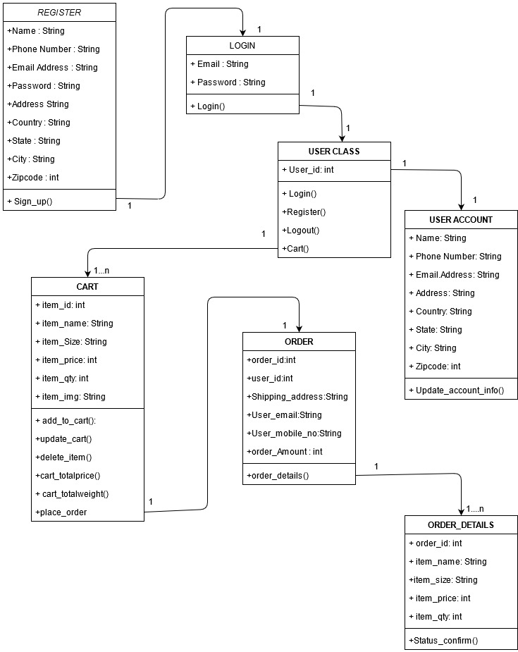

**CLASS DIAGRAM FOR PRODUCT:**

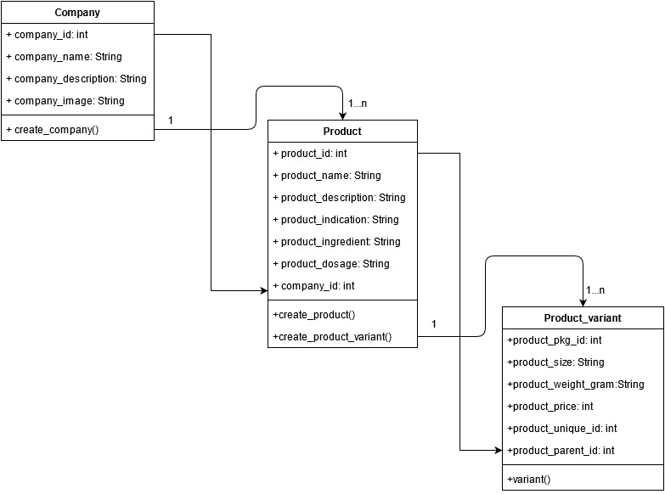

**USE CASE DIAGRAM :**

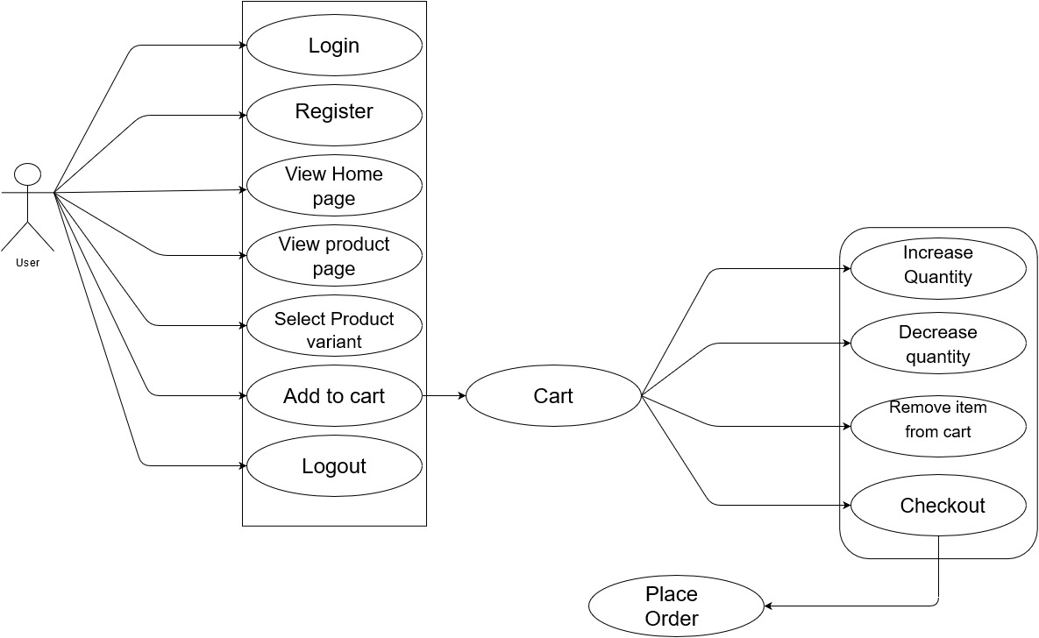

**SEQUENCE DIAGRAM :**

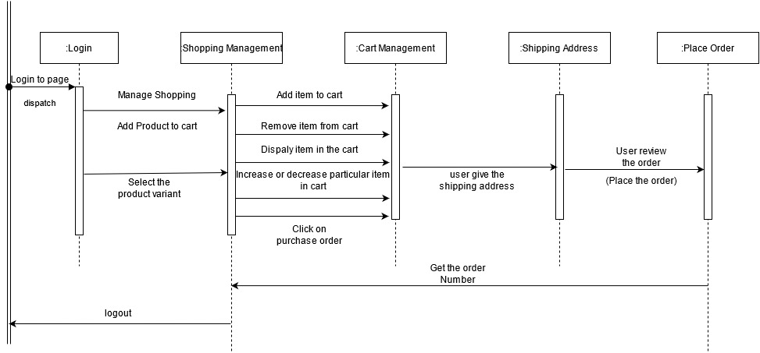

**OBJECT DIAGRAM:**

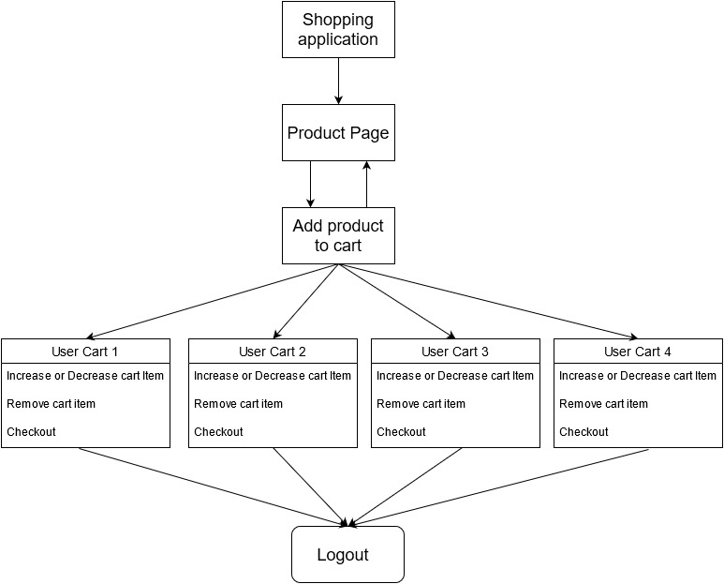

**ACTIVITY DIAGRAM:**

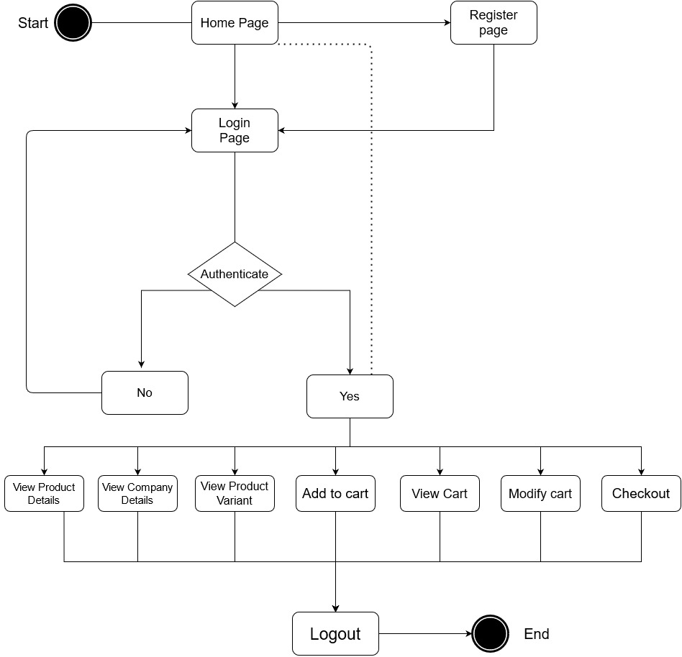

**COMPONENT DIAGRAM:**

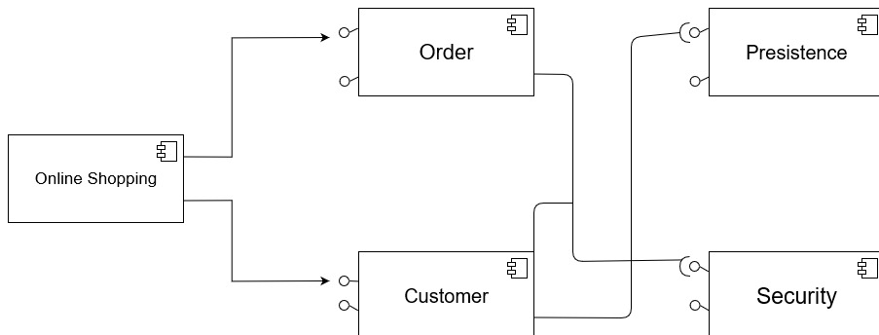

**STATE DIAGRAM:**

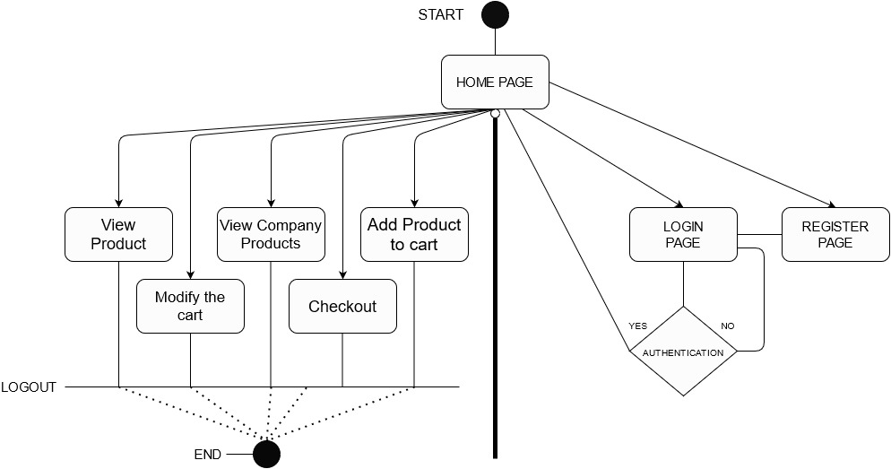

**DEPLOYMENT DIAGRAM:**

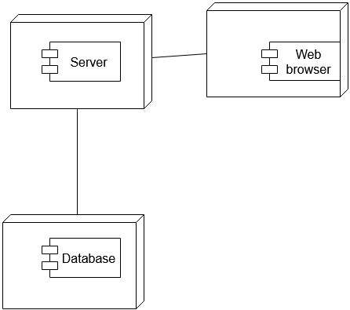

**PACKAGE DIAGRAM:**

**PACKAGE DIAGRAM:**

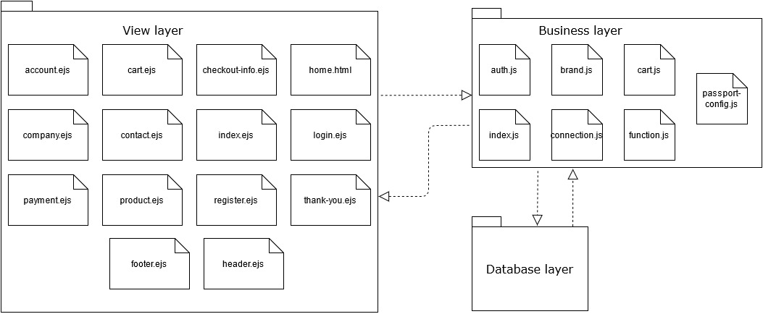

**SYSTEM CODING .**

**VALIDATIONS:**

The following Validation are used in the web Application:

**1.Login Page:**

* During the login process the system checks weather the inputs given by the user matches with any records in the database. If not than system throws exception with the message **“Invalid username or Password”.**
* Login page does not take any of *the input field as Empty* if any it throws an exception by highlighting that empty field in **Red Colour**.

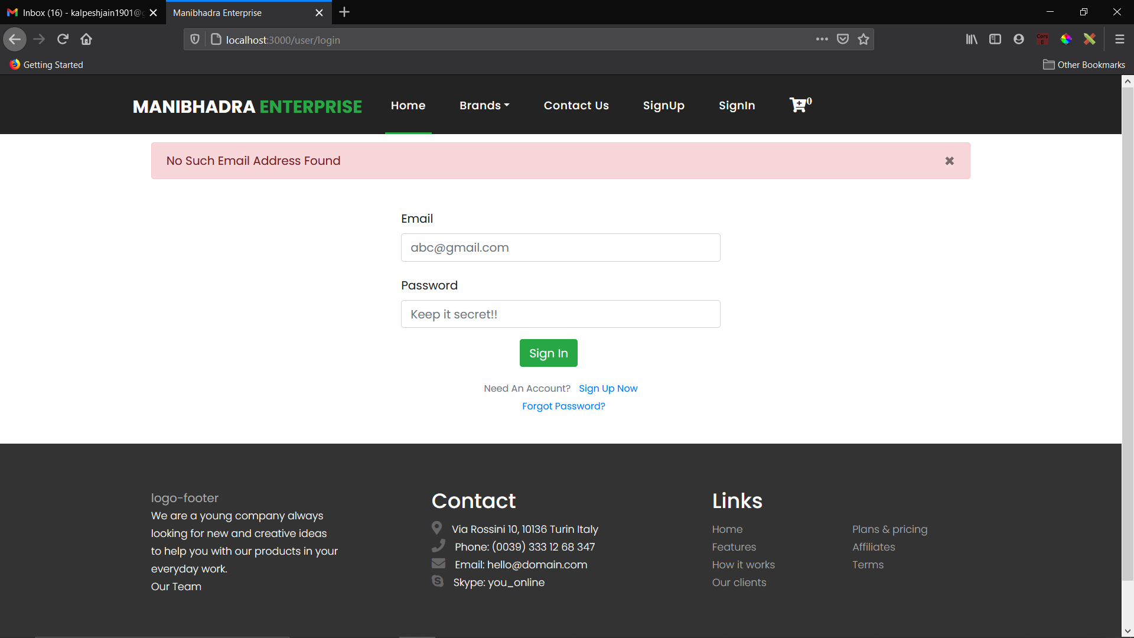

**2.Register Page:**

* While registering the new user to the application the system check weather the *Username & Mail Address given are already* exist in the database. If it does than the System throws exception message **“Username already exist”** & **“Email already exist”.**
* Username provided should be *Greater than 2 & Less than 15 character* or else system make exception of **“Field must be between 2 and 15 characters long”** & if the *Email format does not matches* with regular Expression it throws exception message **“Invalid email address”.**
* Register page does not take any of the *input field as Empty* if any it throws an exception by highlighting that empty field in **Red Colour**.

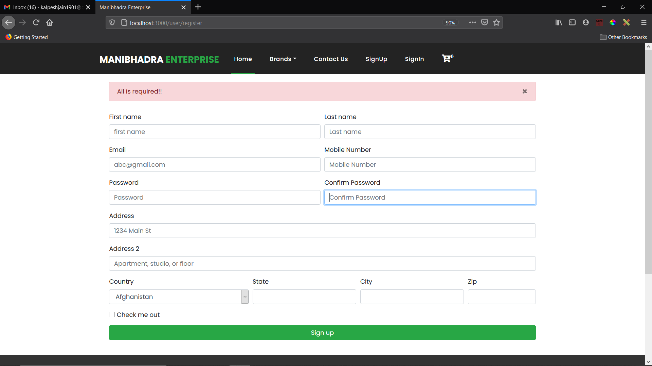

**3.Update Account Information Page:**

* As shown in the image below the *system does not Update* the “Username & Email Address” if they already exist in the database.
* This page does not take any of the *input field as Empty* if any it throws an exception by highlighting that empty field in **Red Colour**.
* Username provided should be *Greater than 2 & Less than 15 character* or else system make exception of **“Field must be between 2 and 15 characters long”.**

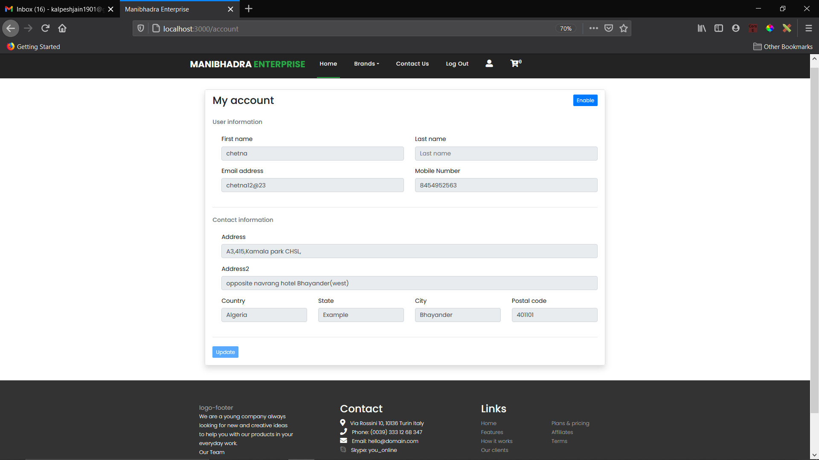

**4.Cart Page:**

* User cannot decrease the quantity of the product less than 1 .
* User can Increase or decrease the quantity using the increment and decrement button inside the product card.
* User can remove the product from the cart and the Total price of the cart will update automatically.

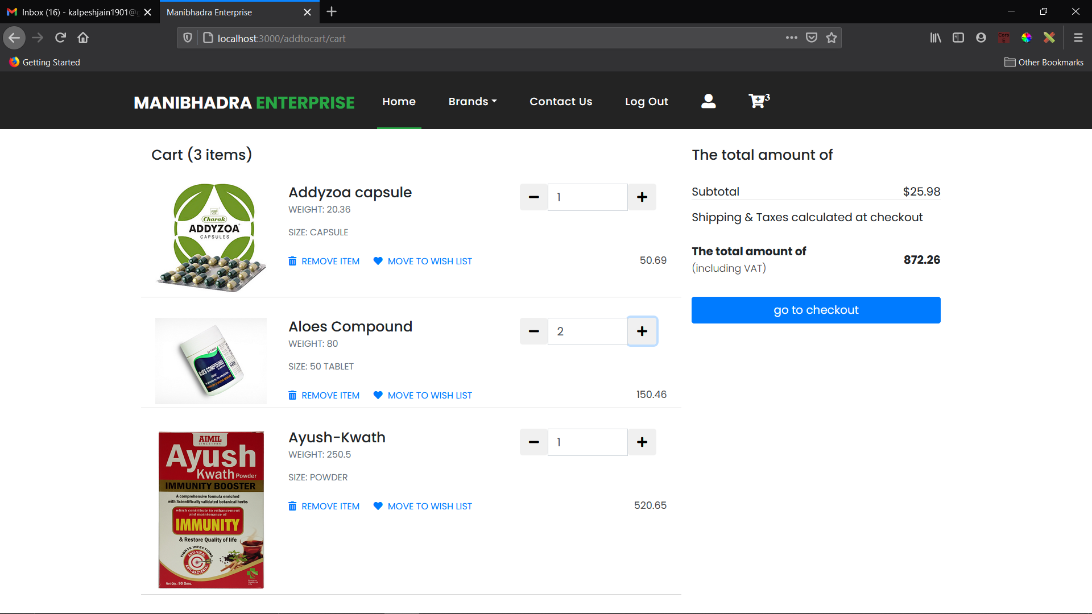

**5.Specific Product Page:**

* User can visit the specific product page .
* Select the Quantity of the product and than add the product to the cart.
* User can also see the Available variants of the of the product if any and click on the variant option and can see the Price of that variant and than add the Quantity to the variant and add the variant to the cart.

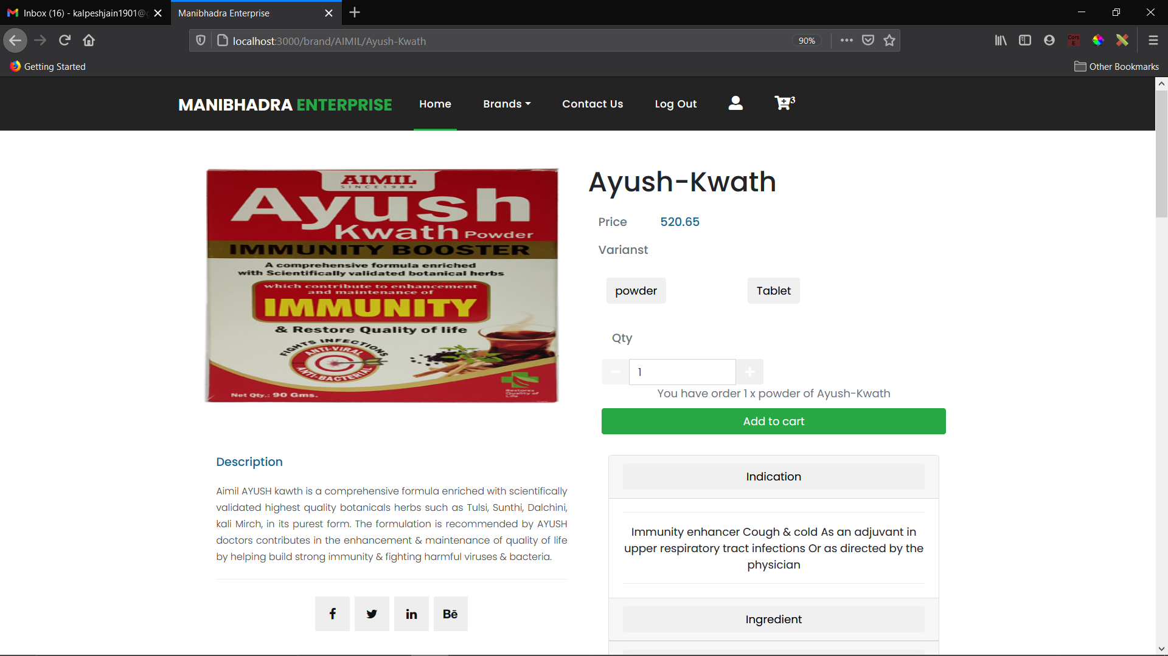

**TEST CASE, TEST DATA & TEST RESULT:**

|  |  |  |  |  |  |  |
| --- | --- | --- | --- | --- | --- | --- |
| **Form Name** | **Test condition** | **Step Procedure** | **Input Test Data** | **Expected**  **Output** | **Actual**  **Output** | **Result** |
| Login .html | Login (button) | Enter only Mail-address | Mail: chetna12@gmail.com | Highlight the password field in red colour. | Highlight the password field in red colour. | **PASS** |
|  |  | Enter only Password | Password: 112233 | Highlight the Email field in red colour. | Highlight the Email field in red colour. | **PASS** |
|  |  | Enter non-registered Username & Password | Mail: chi-nuyenge@gmail.com, Password: DMq5Gzk7zPS6EhB | Invalid username and password!!! | Invalid username and password!!!. | **PASS** |
|  |  | Enter registered Username & Password | Mail: [nguyenchi@gmail.com](mailto:nguyenchi@gmail.com), Password: DMq5Gzk7zPS6EhB | Login successful (Redirect to index.ejs) | Login successful (Redirect to index.ejs) | **PASS** |
| Register. html | Sign Up (button) | Enter only 1 Character Username & other above 15 character | Username: ‘k’ or ‘rohanponawallaaa’ | Field must be between 2 and 15 characters long. | Field must be between 2 and 15 characters long. | **PASS** |
|  |  | Enter Username which already exit in the database | Username: ‘chi-nguyen’ | Username Already exist | Username Already exist | **PASS** |
|  |  | Enter Mail-Address which already exit in the database | Email: [nguyenchi@gmail.com](mailto:nguyenchi@gmail.com) | Email Already exist | Email Already exist | **PASS** |
|  |  | Enter Mail-Address with different mail format | Email: nguyenchi.gmail.com | Invalid email address. | Invalid email address. | **PASS** |
|  |  | Enter mis-matching-Password in Password & Confirm password field | Password: 8S5hsy5XcReSeFm  Confirm Password: 8S5hsy5XcReSeFmm | Field must be equal to password | Field must be equal to password | **PASS** |
|  |  | Enter invalid format of phone number | Phone No.  845579621 | Invalid Phone Number | Invalid Phone Number | **PASS** |
|  |  | Leaving Any Input field Blank |  | All field are required | All field are required | **PASS** |
|  |  | Enter all the field correctly | Username: chi-nguyen,  Emai: [nguyenchi@gmail.com](mailto:nguyenchi@gmail.com),  Password: 8S5hsy5XcReSeFm,  Confirm-password: 8S5hsy5XcReSeFm | Register Successful Redirect to (Login.html) | Register Successful Redirect to (Login.html) | **PASS** |
| Cart.ejs | Increment & Decrement Button | Giving the input field the value to Zero | Input Field  (Zero = “0”) | Quantity of the Product in cart cannot be Equal to Zero | Quantity of the Product in cart cannot be Equal to Zero | **PASS** |
| Update.ejs | Update (Button) | Updating the Email field By giving the Email address which Is already in the database | Email-Address  Chetna12@gmailcom | Please check the Mail Address Once Again  The provided Mail address is already taken. | Please check the Mail Address Once Again  The provided Mail address is already taken. | **PASS** |

**SCREEN LAYOUTS**

**1.Login Page:**

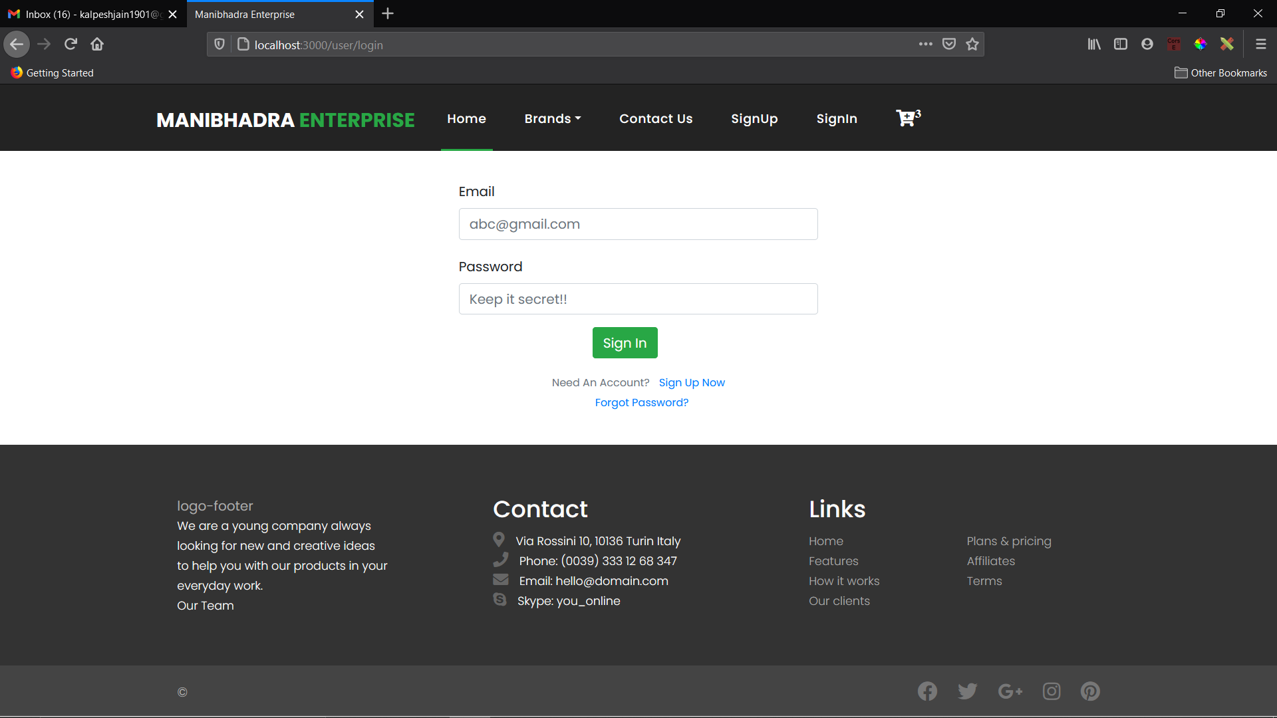

**2.Register Page:**

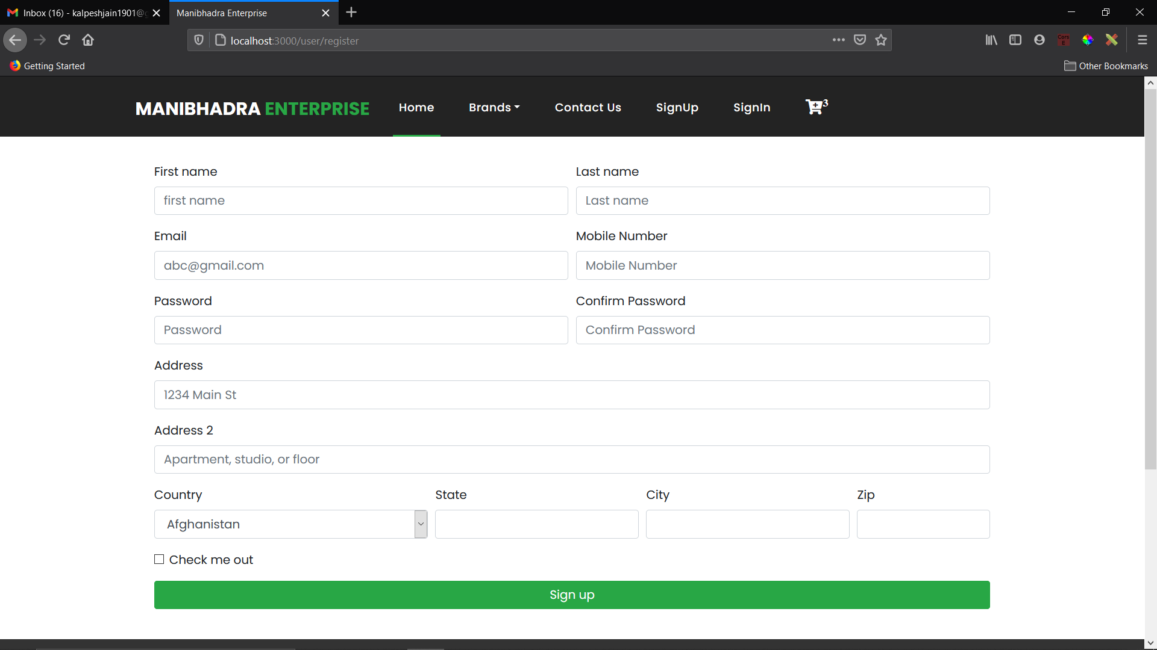

**3.Home Page:**

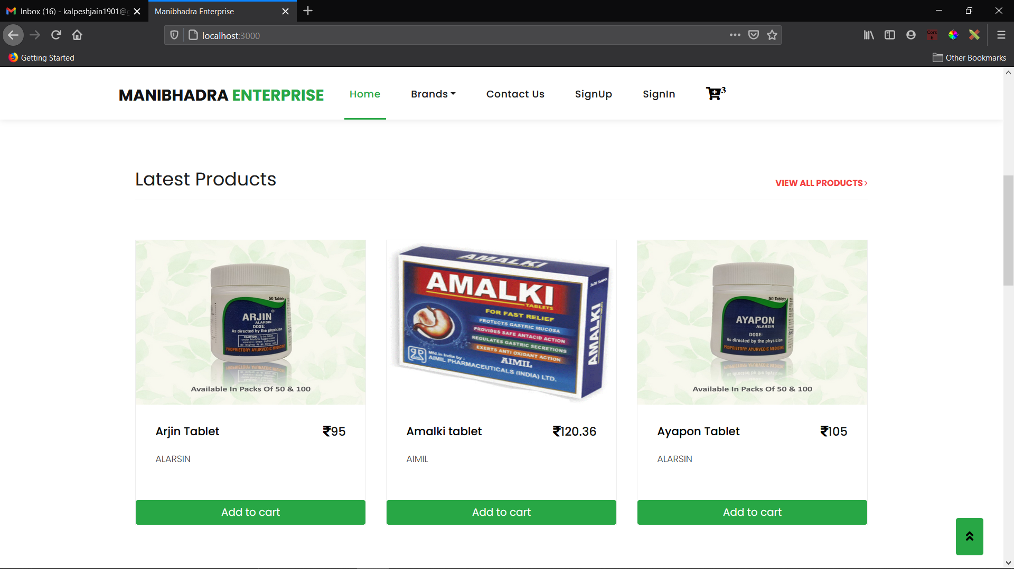

**4.Company Page:**

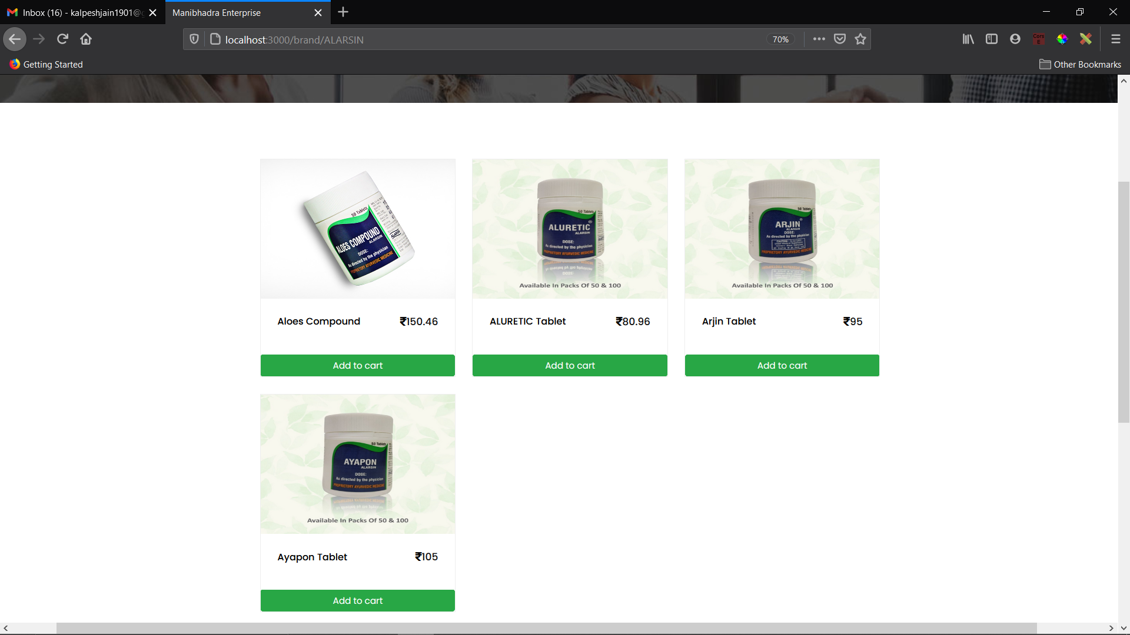

**5.Product Page:**

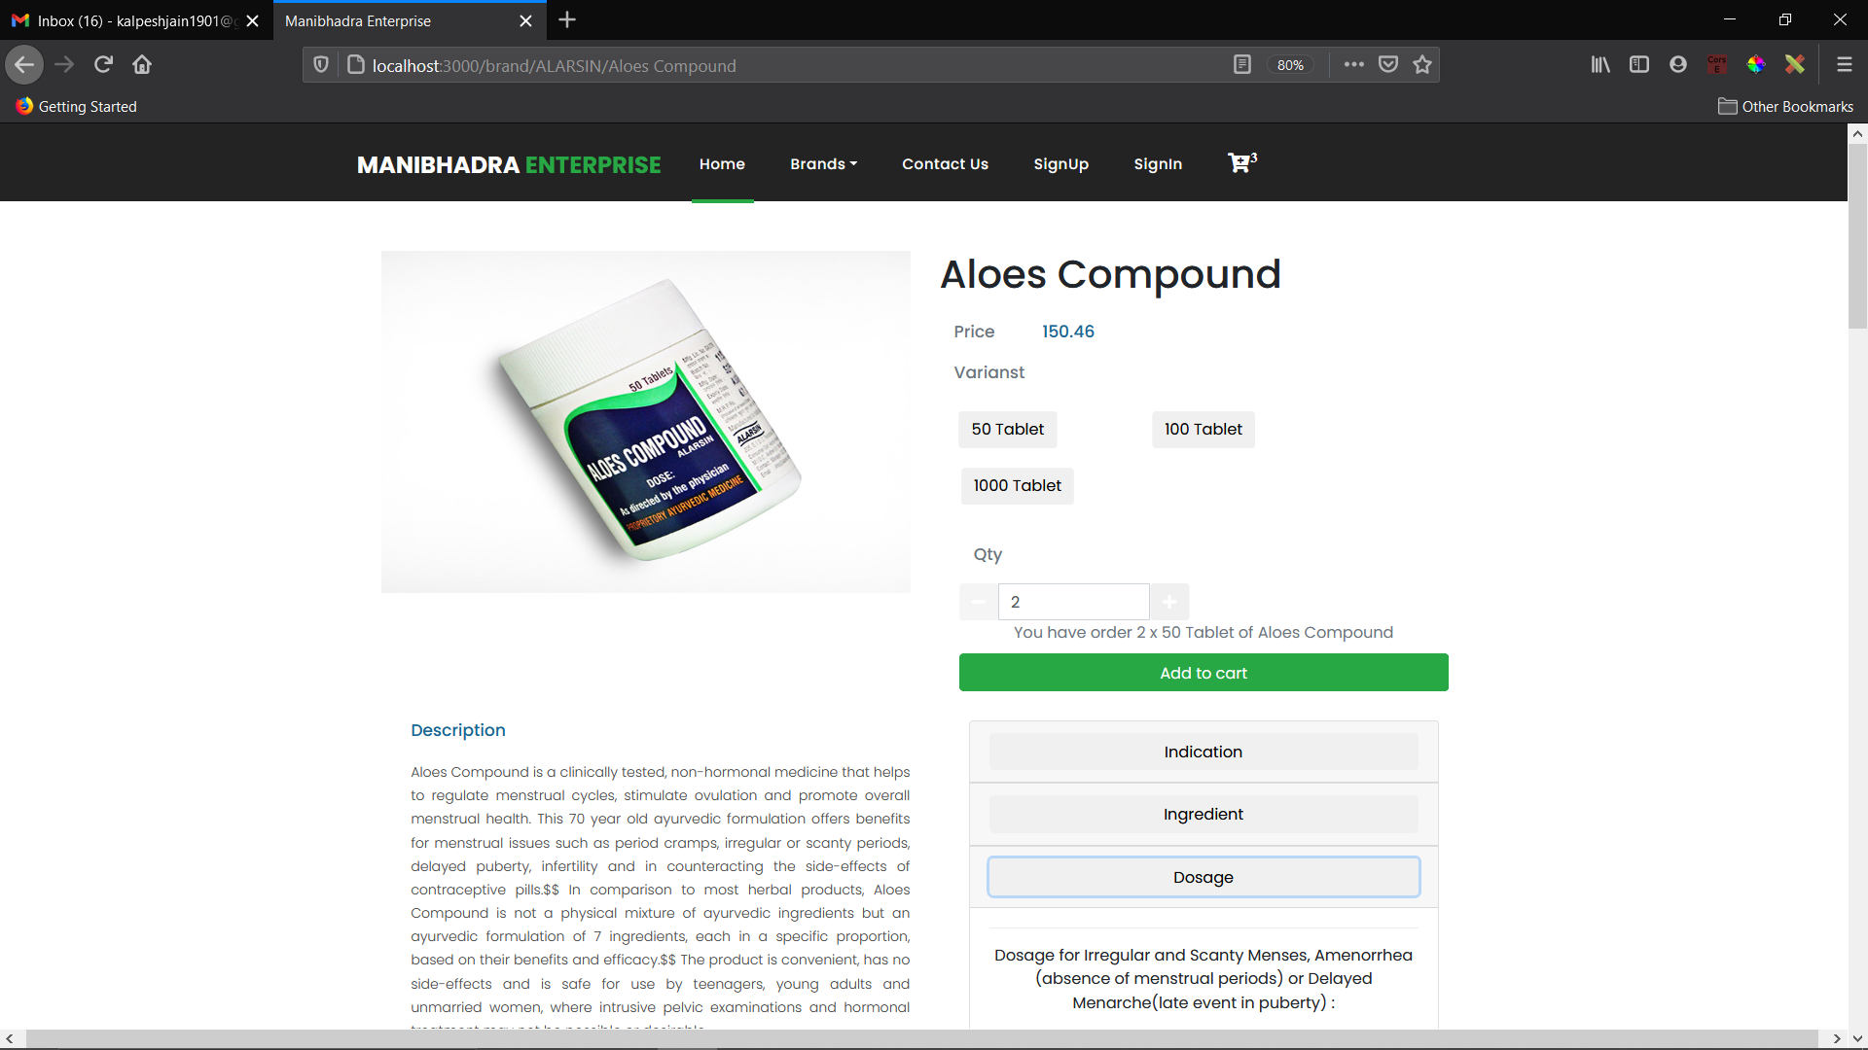

**6.Cart Page:**

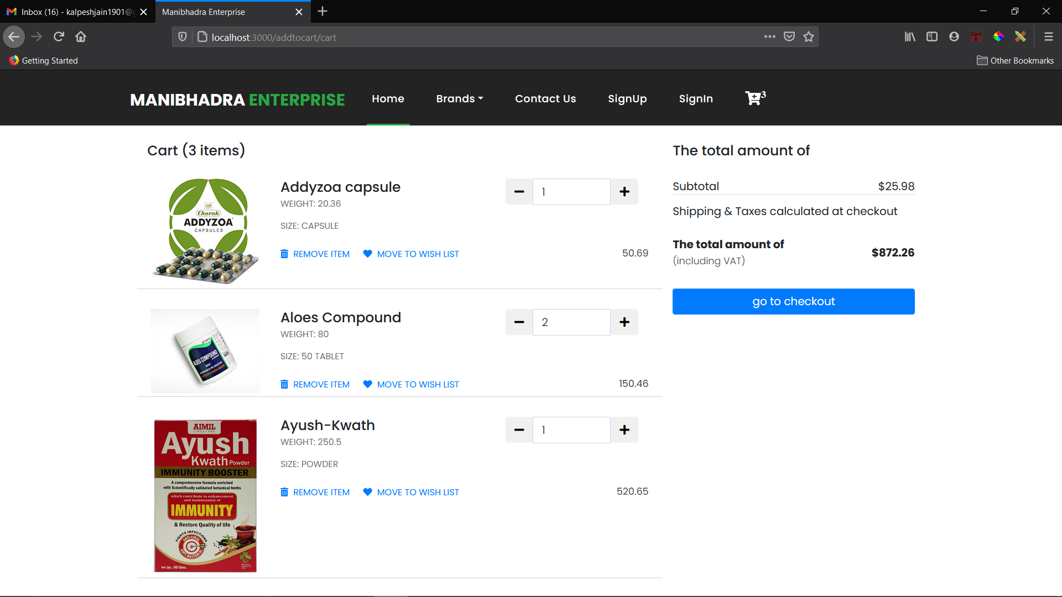

**7.Shipping address details Page:**

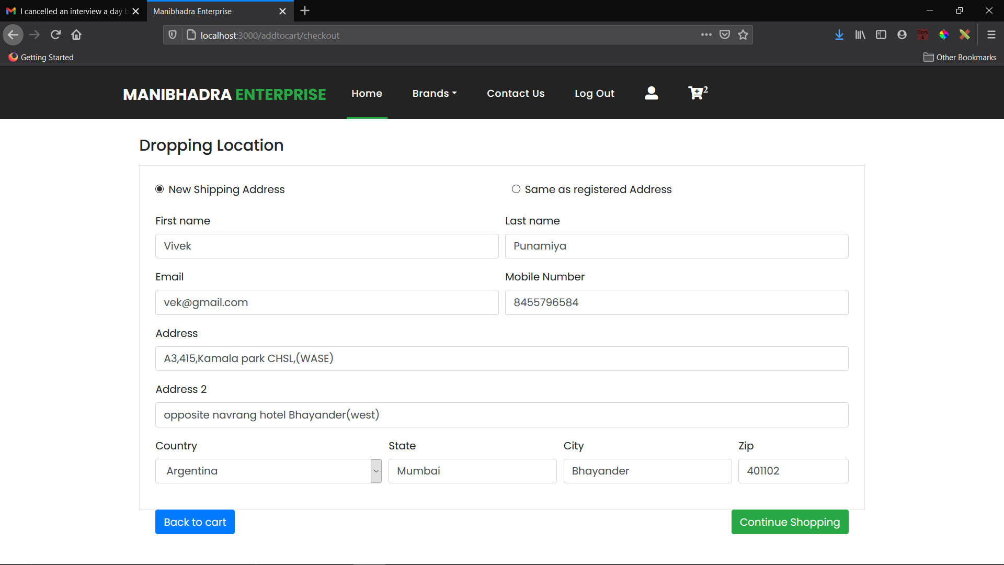

**8.Invoice Page:**

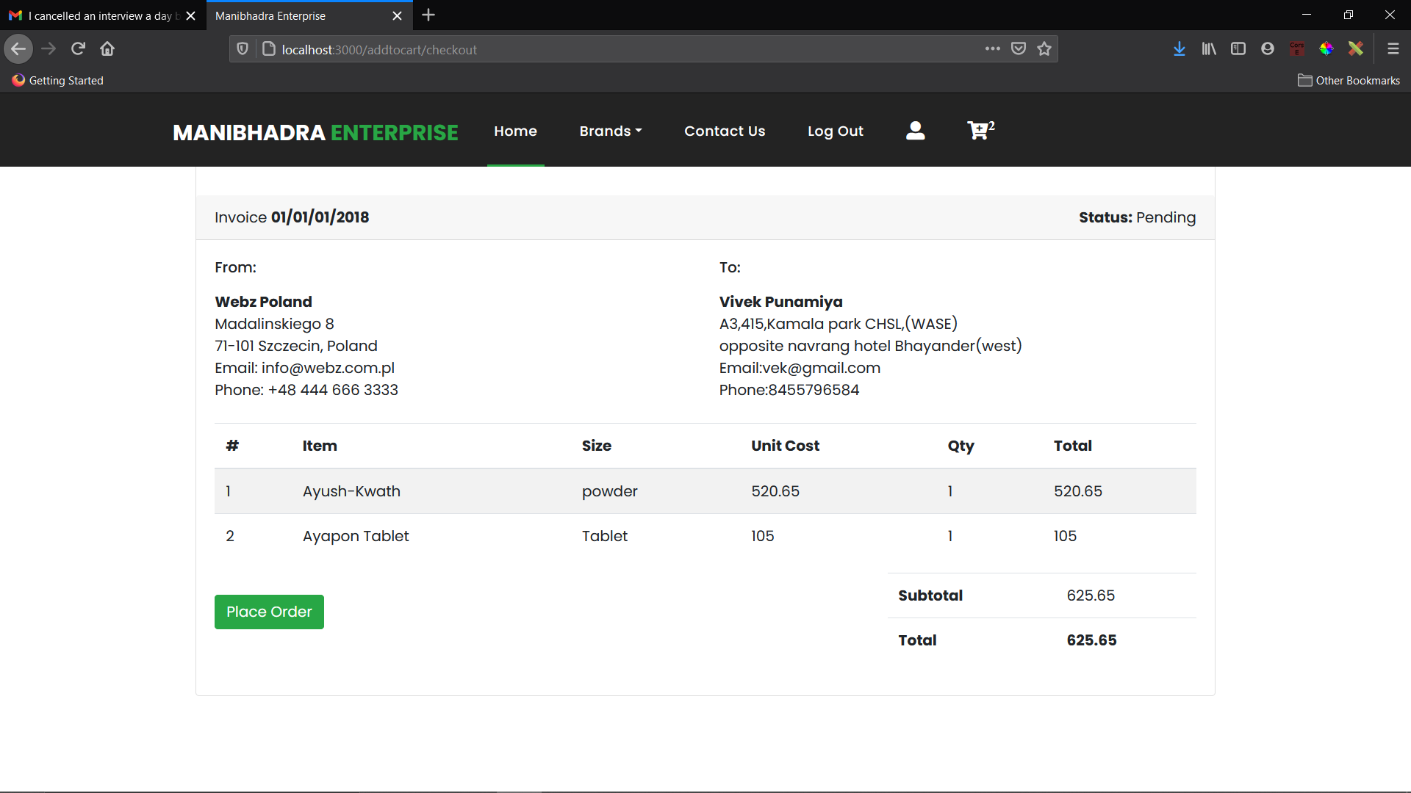

**9: Thank-you page:**

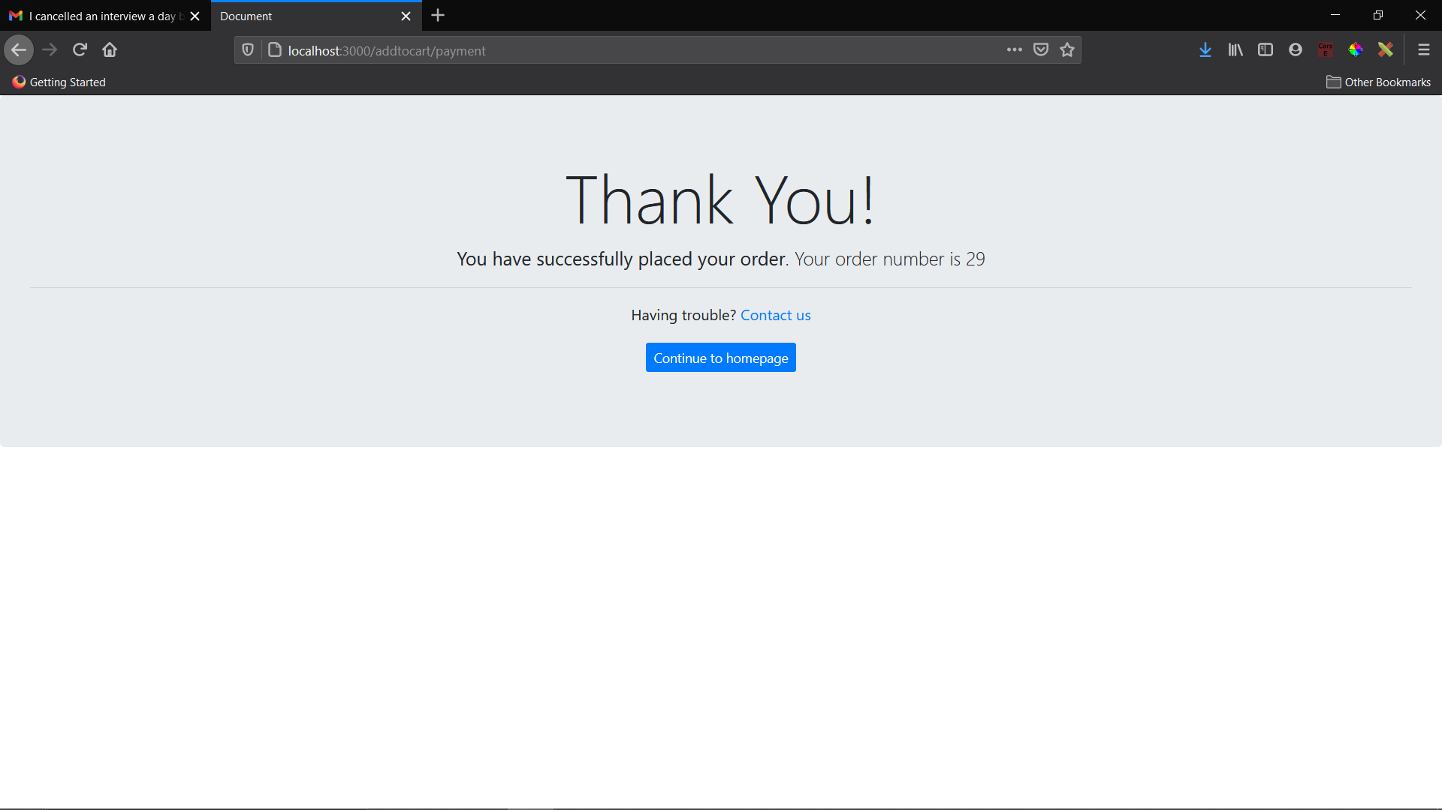

**SYSTEM IMPLEMENTATION:**

* Purchase the web hosting space and website domain so that it will be accessible by everyone over the internet.
* Install a web server such as apache that will help manage the requests and send responses.
* Install the MySQL server to store and manage the data.
* Install phpMyAdmin to easily handle the MySQL server.
* Install flask for backend scripting.
* Upload all the files on the hosted space, connect it to domain name so that it is easier to find.
* Now to use from the client side only a web browser is required.

**CONCLUSION & FUTURE SCOPE:**

New studies projected that the worldwide retail eCommerce sales will reach a new high by **2021**. Ecommerce businesses should anticipate a 265% growth rate, from $1.3 trillion in 2014 to $4.9 trillion in **2021**. This shows a future of steady upward trend with no signs of decline.

**Electronic commerce** draws on such innovations as **electronic** funds transfer, supply chain management, Internet marketing, online exchange preparing, **Electronic** Data Interchange (EDI), inventory frameworks, and computerized information assortment frameworks.

**FUTURE ENHANCEMENT:**

* Improved UI/UX Design.
* Adding some more exiting feature to the site such as commenting & liking system, integrated chatting system, Admin management, etc.

**BIBLIOGRAPHY:**

* [**https://nodejs.org/en/**](https://nodejs.org/en/)
* [**https://expressjs.com/**](https://expressjs.com/)
* [**https://stackoverflow.com/**](https://stackoverflow.com/)
* [**http://www.passportjs.org/**](http://www.passportjs.org/)
* [**https://ejs.co/**](https://ejs.co/)
* [**https://getbootstrap.com/docs/4.1/getting-started/introduction/**](https://getbootstrap.com/docs/4.1/getting-started/introduction/)

